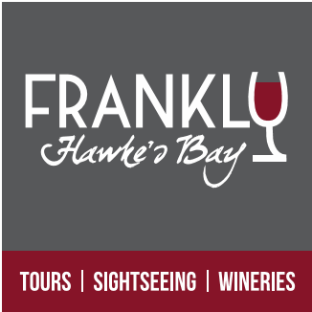

Cruise Boat Hawke’s Bay Excursion
HAWKE’S BAY SCENIC WINERY TOUR
5+ hours

Tour timetabled to meet ship arrival and departure.
$125pp

A varied and insightful tour showcasing the heritage, rural vistas and produce of the Hawke’s Bay region in and around the cities of Napier, Hastings and the village of Havelock North. Small tour groups and personalised (max 10)

- A Guided understanding of Napier’s Art Deco Heritage and History.
- Enjoy the Views from Bluff Hill (photo opportunity)
- Visit the historic Mission Estate Winery (NZs Oldest) incl tasting
- Enjoy the rural scenery and commentary as we head out to the Gimblett Gravel Wine Region
- Visit and sample wine at 2 Boutique wineries including a gourmet platter
- Winery lunch (own cost)
- Visit and sample NZ Honey at Arataki Honey House.
- Marvel at the breath-taking 360deg views from Te Mata Peak.
- Visit and sample freshly picked Berries, Apples, peaches... at the source (seasonal availability) with a fresh fruit ice cream.

Please note: This itinerary could change or substitute in order to avoid weather conditions.
Winery tasting fees included
Deposit not required – Payment due when we meet ashore on the day.
To book your seats please email : info@franklytours.nz

